**Guided Capstone Project Report (for business audience)**

**1. Business problem definition**

What changes can be implemented to cut costs while justifying the same or higher ticket price setting to generate profit more than $1,540,000 within a season?

**2. Data problem definition**

Which facilities/features of resort contribute to higher price setting by what degree? Using a model that predicts appropriate ticket price in relationship with the facilities/features the ski resort carries, we can estimate the ticket price when we cut operational cost of certain facilities/features to generate overall profit.

Limitations: The dataset provided to build the model is missing number of visitors and duration of stay of the visitors. Therefore the model built with this data will be missing the relationship of ticket price and number of visitors and their duration of stay.

Assumption: prices are set by free market. The ticket price does not affect the number of visitors and their duration of stay.

**3. Model selection**

Linear regression model and random forest model was compared using median to impute missing value and 5 fold cross-validation. Although both models gave test set performance consistent with cross-validation results, the random forest model resulted in a lower cross-validation mean absolute error by almost $1 with less variability. Therefore, random forest model was chosen for further analysis

**4. Model outcome**

Big Mountain currently charges $81 and modelled price is $95.87 (calculated by refitting the model with all the data except for Big Mountain resort). There is room to increase the current price even with the expected mean absolute error of 10.39 dollars.

Big Mountain resort has more vertical drop and number of runs than most of the resorts, and has amongst the largest snow making area, highest number of total chairs/fastquads, and the longest runs. These are the traits that can justify the increase in current ticket price (Figure 1a-f). On the other hand, we need to keep in mind that the Big Mountain resort's current price is already the highest within the Montana State, and Big Mountain resort carries one of the largest skiable terrain and thereby can host more visitors, which are the factors that can justify increasing the ticket price by NOT too much (Figure 1h,i).

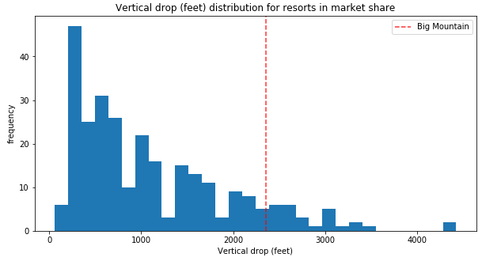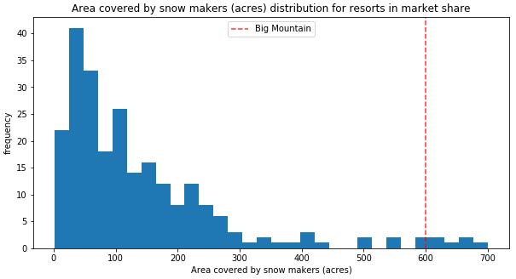

**b**.

**a**.

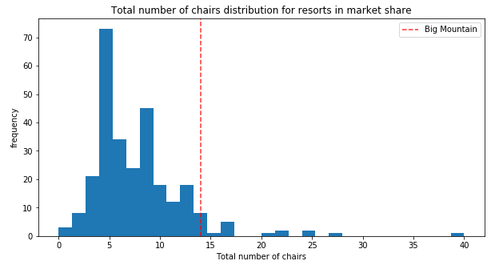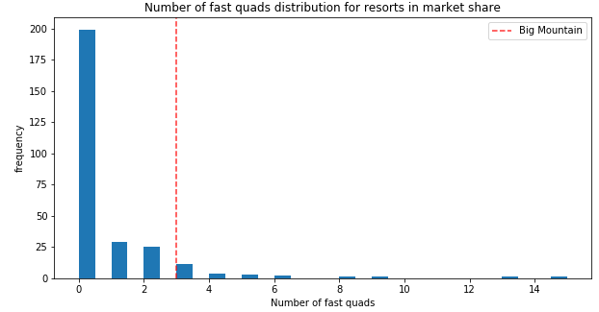

**c**

**d**

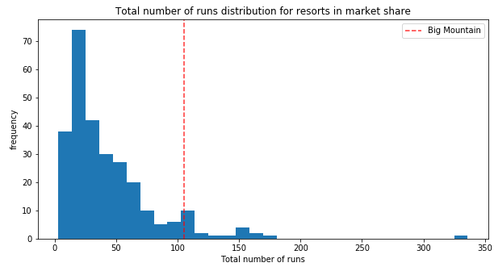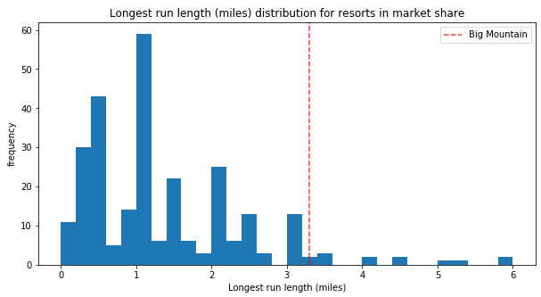

**f**

**e**

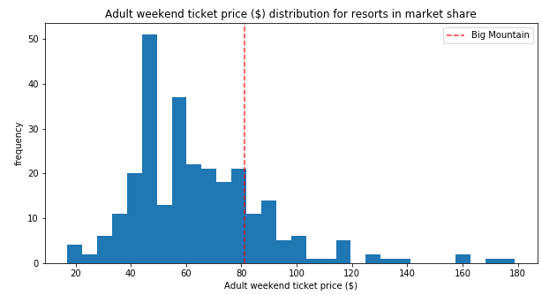 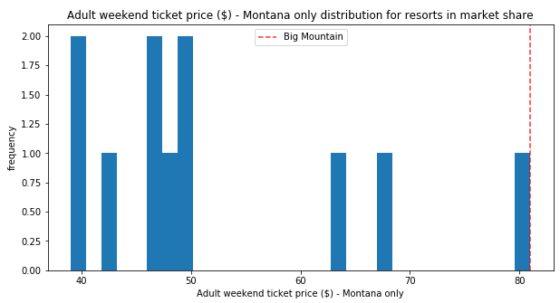

**h**

**g**

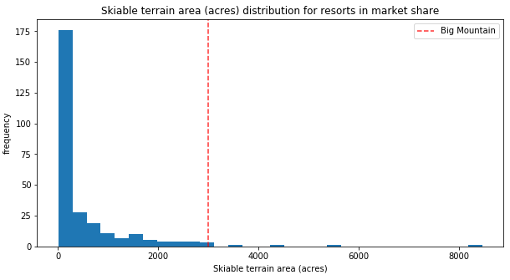

**Figure 1**. Big Mountain resort in market context of following features: (a) vertical drop, (b) snow making area, (c) total number of chairs, (d) fast quads, (e) total number of runs, (f) length of longest run, (g) adult weekend ticket price (all states), (h) adult weekend ticket price (Montana only), and (i) skiable terrain area. Big Mountain resort's value is marked with a red vertical line.

**i**

Modelled ticket price was calculated for following scenarios that the business has shortlisted:

1. Permanently closing down up to 10 of the least used runs. This doesn't impact any other resort statistics.
2. Increase the vertical drop by adding a run to a point 150 feet lower down but requiring the installation of an additional chair lift to bring skiers back up, without additional snow making coverage
3. Same as number 2, but adding 2 acres of snow making cover
4. Increase the longest run by 0.2 mile to boast 3.5 miles length, requiring an additional snow making coverage of 4 acres

We assumed the expected number of visitors over the season to be 350,000 and, on average, visitors ski for five days. We also assumed the provided data includes the additional lift that Big Mountain recently installed.

* Senario1: Closing one run makes no difference while closing 2 and 3 runs successively reduces support for ticket price and so revenue. If Big Mountain closes down 3 runs, it seems they may as well close down 4 or 5 as there's no further loss in ticket price. Increasing the closures down to 6 or more leads to a large drop (Figure2). 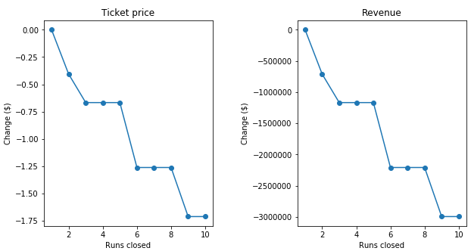

**Figure 2**. Predicted ticket price change (a) and its corresponding revenue change (b) for each number of runs closed. Assumed expected number of visitors to be 350,000 and each of the expected visitors buys 5 tickets.

* Senario2: This scenario increases support for ticket price by $1.99. Over the season, this could be expected to amount to $3474638 revenue.
* Senario3: This scenario increases support for ticket price by $1.99. Over the season, this could be expected to amount to $3474638 revenue. Such a small increase (2 acres) in the snow making area makes no difference in ticket price.
* Senario4: This scenario increases support for ticket price by $0.00. Increasing the longest run by 0.2 mile makes no difference at all in ticket price. This is because the random forest model only has longest run way down in the feature importance list.

**5. Recommendation**

Assuming the operating costs of an additional chair lift in Scenario 2 & 3 is $1,540,000 per season, we only need to increase the ticket price by $0.88 (= 1,540,000 / (5 x 350,000)) to cover the cost. Therefore, Scenario 2 with $1.99 increase in ticket price should produce $1,934,638 (= 3,474,638 - 1,540,000) profit. Although adding the 2 acres of snow making cove in scenario 3 does not contribute to increase in ticket price, it should be a necessary procedure to make the newly developed area in scenario 2 skiable.

For future improvements, modeled scenario 3 is recommended for further consideration (need information on operating cost of snow making per acre). If the operating cost to maintain 5 runs is more than the ticket price drop due to the 5 run closures (around $1,200,000), scenario 1 with 5 run closures is also recommended.